String Programs for Interview:
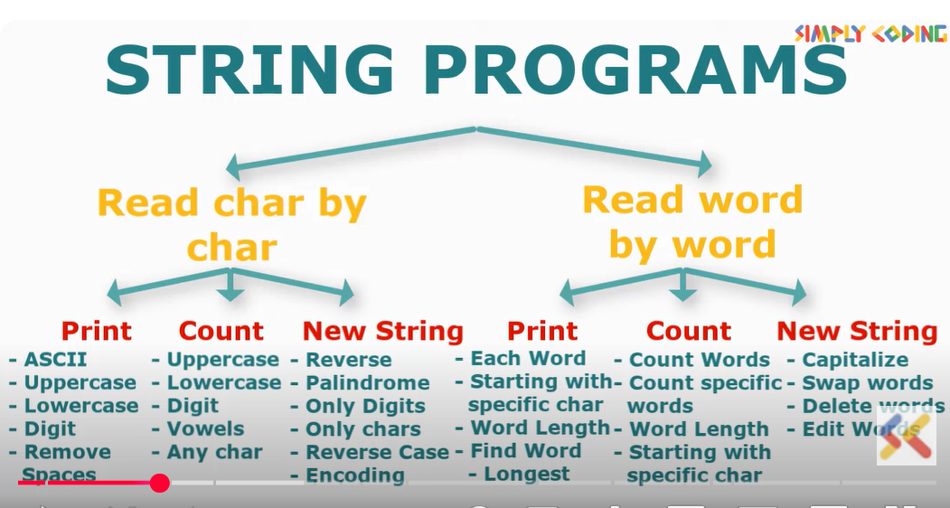

Total Programs:
Character
1.Print each character of the string in separate line
2.Program to print ascii code of each string
3.Print only Uppercase or Lowecase characters of a string
4.Program to count uppercase characters in a string
5.Program to count both uppercase characters and lowercase characters in a string
6.To print digit and count digit
7.To print and count vowels
8.To print and count certain characters

Program to create a String

//1.Create a string for uppercase
2 .Create a string for printing digit first then character
3.Create a String with uppercase first then remaining characters
4.Create a String after removing all the spaces
5.Write a program to reverse the case of a string (eg Sound to sOUND)
6.Write a program to reverse a string (eg Sound to dnuoS)
7.Check if a string is palindrome or NOT

1.Step 1 : String input
3 ways we can have string as input
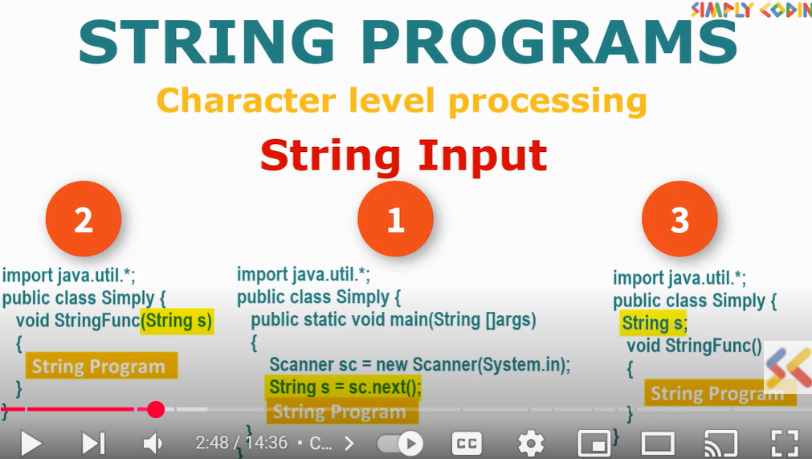
1.Using scanner class
2.Using string function
3.Using instance variable
2.Step 2 :To Solve any string program we have to go character by character which is called String traversal
Solution : Create a template for string traversal ,then 50 percentage problem solved
Then change logic as per question we can resolve any program

In Strings, character are stored in index value like arrays
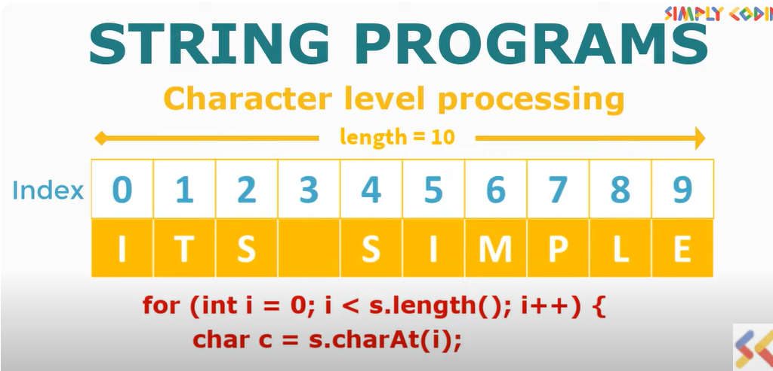

String str = "Automation"; //Stiring input

for(int i=0; i<str.length(); i++) {
char c= str.charAt(i);

}
Output: A
u
t
o
m
a
t
i
o
n

1.Print each character of the string in separate line
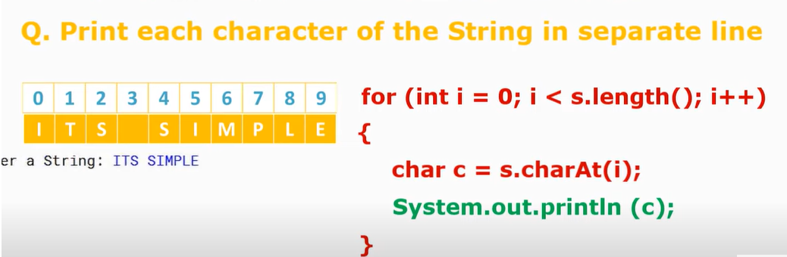
String str = "Automation";
for(int i=0; i<str.length(); i++) {

char c= str.charAt(i);

System.out.println(c);
}

2.Program to print ascii code of each string

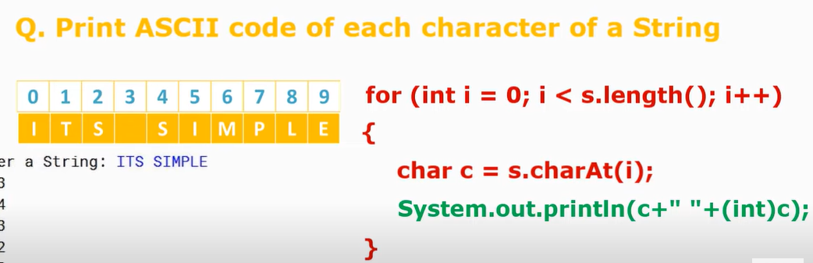
String str = "Tell me";

for(int i=0; i<str.length(); i++) {

char c = str.charAt(i);
System.out.println(c + " " + (int)c );
}

3.Print only Uppercase or Lowecase characters of a string
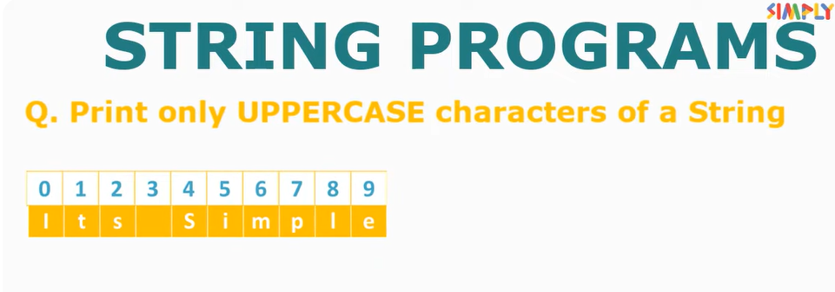
String str = "Its Simple";

for(int i=0; i<str.length(); i++) {

char c = str.charAt(i);

if(Character.isLowerCase(c)) {
System.out.println(c);
}

//for upper case if(Character.isupperCase(c))

4.Program to count uppercase characters in a string
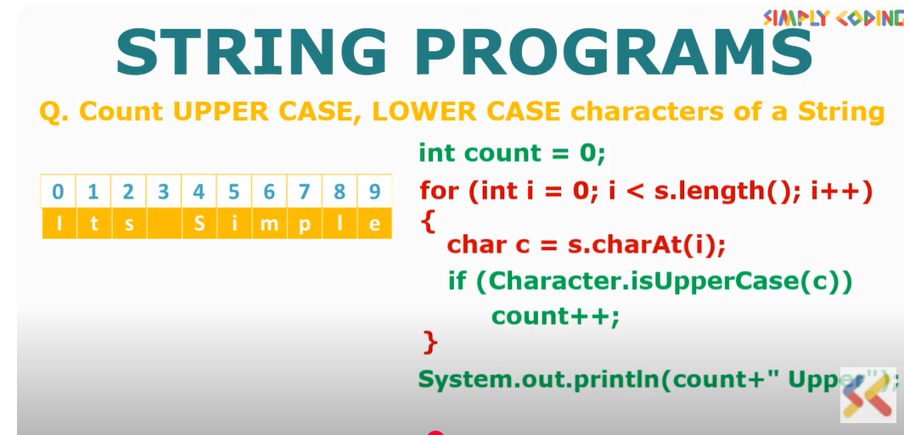
String str = "its Simple";

int count=0;

for(int i=0; i<str.length(); i++) {

char c= str.charAt(i);

if(Character.isUpperCase(c))
count++;

}
System.out.println("Count of upper case is " + count);

}

5.Program to count both upper case and lower case character in a string

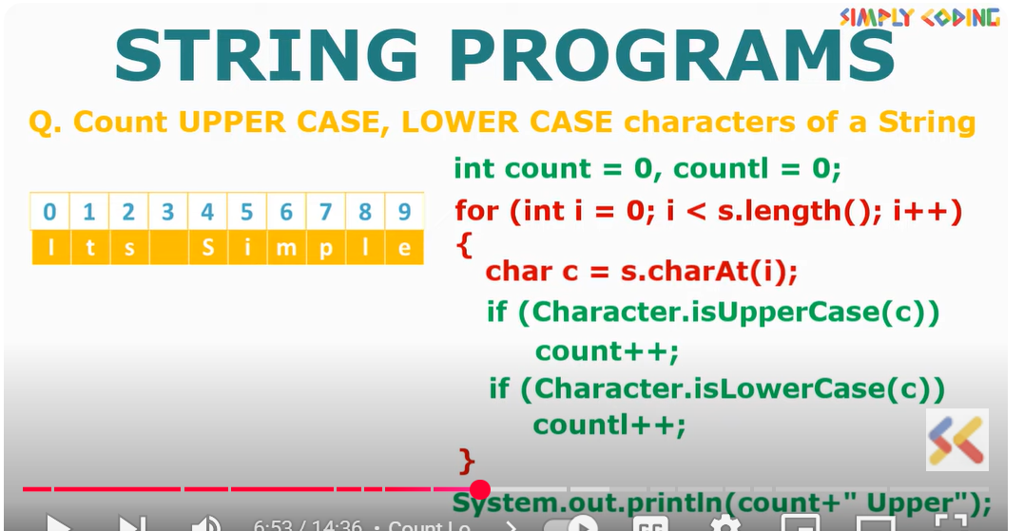

String str = "its Simple";

int count=0;
int countlow =0;

for(int i=0; i<str.length(); i++) {

char c= str.charAt(i);

if(Character.isUpperCase(c))
count++;

if(Character.isLowerCase(c))
countlow++;
}
System.out.println("Count of upper case is " + count);
System.out.println("Count of Lowercase case is " + countlow);

}

//7.To print digit

Simply use if(Character.isDigit(c)

Example
String star = "Nazeer is 1 and 2";

for(int i=0; i<star.length(); i++) {

char c= star.charAt(i);

if(Character.isDigit(c)) {
System.out.println(c);
}
}
}
//8.To print vowels

String stars = "Award";

for(int i=0; i<stars.length(); i++) {

char c= stars.charAt(i);

char ups =Character.toUpperCase(c);

if(ups=='A'||ups=='E'||ups=='I' |ups=='O' | ups=='U') {

System.out.println(ups);

}

9.To print certain characers
//4.Program to print vowels

String str = "AdeR";
int count=0;
for(int i=0; i<str.length(); i++) {
char c=str.charAt(i);

char ups = Character.toUpperCase(c);

if(ups=='R' || ups=='A') {
System.out.println("Yes R or A is present :" + ups);

}

=============================================================================

Program to create a String

//1.Program to create a string for uppercase

Logic:
1.Create a empty string
2.Find the uppercase string and add it in new empty string
3.Print the string

String str = "Ader";
String sn ="";

for(int i=0; i<str.length(); i++) {
char c=str.charAt(i);
if(Character.isUpperCase(c)) {
sn = sn + c;
}

}
System.out.println(sn);

2.Create a String with digit first then character
//create a new string with digit first then characters

Logic:
1.create a two empty string
2.Filter digit using characterisdigit
3.Filter remainder characters with else
4.Add both in empty string
5.print both

String str = "Lucky 4day 1NAZEER";
String d = "";
String r="";
String all = "";

for(int i=0; i<str.length(); i++) {
char c =str.charAt(i);

if(Character.isDigit(c)) {
d = d + c;
}else {
r = r+c;
}

}

all = d + r;

System.out.println(all);

3.Create a String with uppercase first then remaining characters
Same program like Create a String with digit first then character but only change is uppercase method
Logic:
1.create a two empty string
2.Filter digit using characterisuppercase
3.Filter remainder characters with else
4.Add both in empty string
5.print both
Note : use lowercase method for lowercase

4.Create a String after removing all the spaces
Logic:
1.Use template and use Character NOT equal to whitespace method
public static void main(String[] args) {

//create a new string with digit first then characters

String str = "Lucky 4day 1NAZEER";
String d = "";

for(int i=0; i<str.length(); i++) {

char c =str.charAt(i);

if(!Character.isWhitespace(c)) {
d=d+c;
}

}
System.out.println(d);

}

5.Write a program to reverse the case of a string (eg Sound to sOUND)

String fun = "Nazeer1 is 2way and 3side";
String upper = "";
String lower = "";
String digi = "";

for (int i = 0; i < fun.length(); i++) {
char c = fun.charAt(i);

if (Character.isUpperCase(c)) {
upper += Character.toLowerCase(c);
} else if (Character.isLowerCase(c)) {
lower += Character.toUpperCase(c);
} else if (Character.isDigit(c)) {
digi += c;
}
}

System.out.println("Lowercase to Uppercase: " + lower);
System.out.println("Uppercase to Lowercase: " + upper);
System.out.println("Digits: " + digi);

6.Write a program to reverse a string (eg Sound to dnuoS)

Logic :
1.Empty string and Have change str = c + str or rev = c + rev makes the value reversed

String fun = "Jawa";
String rev = "";
for (int i = 0; i < fun.length(); i++) {
char c = fun.charAt(i);
rev = c + rev;
}
System.out.println(rev);

7.Check if a string is palindrome or NOT
String fun = "Jawa";
String rev ="";

for(int i=0; i<fun.length(); i++) {
char c =fun.charAt(i);

rev = c + rev;

}

if(rev.equalsIgnoreCase(rev)) {

System.out.println("Palindrome");
}else {
System.out.println("NOT Palindrome");
}

}

String Encoding Program – Pigaltin
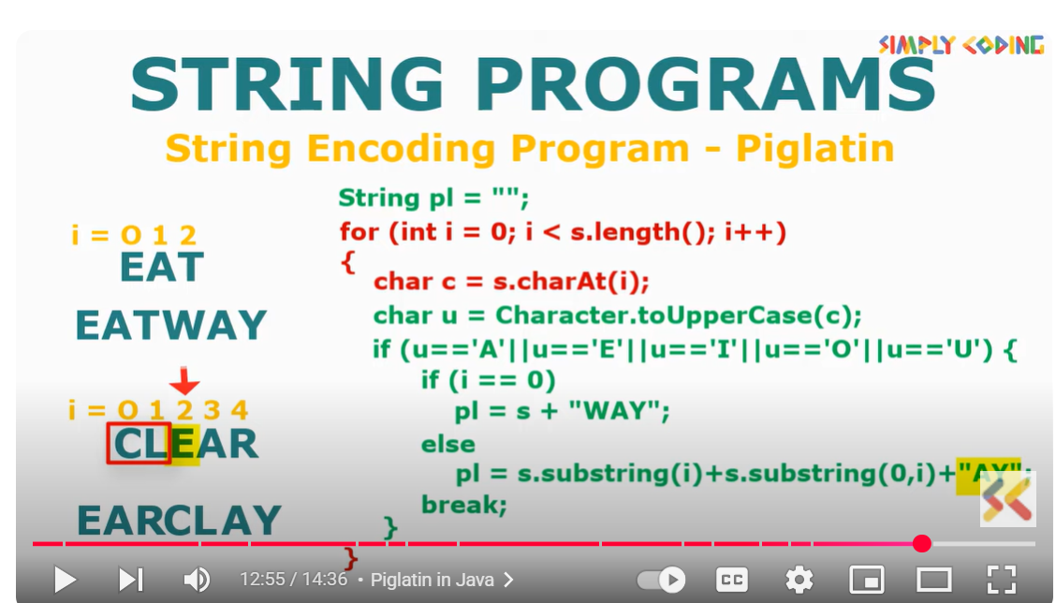
s.substring(i)
- substring(i) → takes the part of the string starting from index i up to the end.
- Example:
- String s = "CLEAR";
- int i = 2; // vowel 'E' at index 2
s.substring(2) → "EAR"
s.substring(0, i)
- substring(0, i) → takes the part of the string from index 0 up to (but not including) index i.
- Example:
- String s = "CLEAR";
- int i = 2;
s.substring(0, 2) → "CL"

public class PigLatinConverter {
public static void main(String[] args) {
String str = "CLEAR";
String pl = "";
for (int i = 0; i < str.length(); i++) {
char c = str.charAt(i);
char u = Character.toUpperCase(c);
if (u == 'A' || u == 'E' || u == 'I' || u == 'O' || u == 'U') {
if (i == 0) {
pl = str + "WAY";
} else {
pl = str.substring(i) + str.substring(0, i) + "AY";
}
break;
}
}
System.out.println(pl);
}
}

What is Piglatin?
Piglatin is a fun encoding rule for words:
- If the word starts with a vowel (A, E, I, O, U) → add "WAY" to the end.
  - Example: EAT → EATWAY
- If the word starts with a consonant → move all letters before the first vowel to the end, then add "AY".
  - Example: CLEAR → EARCLAY

